1. Landing Page (Home)
   1. User can visit either the Register or Login Page
   2. 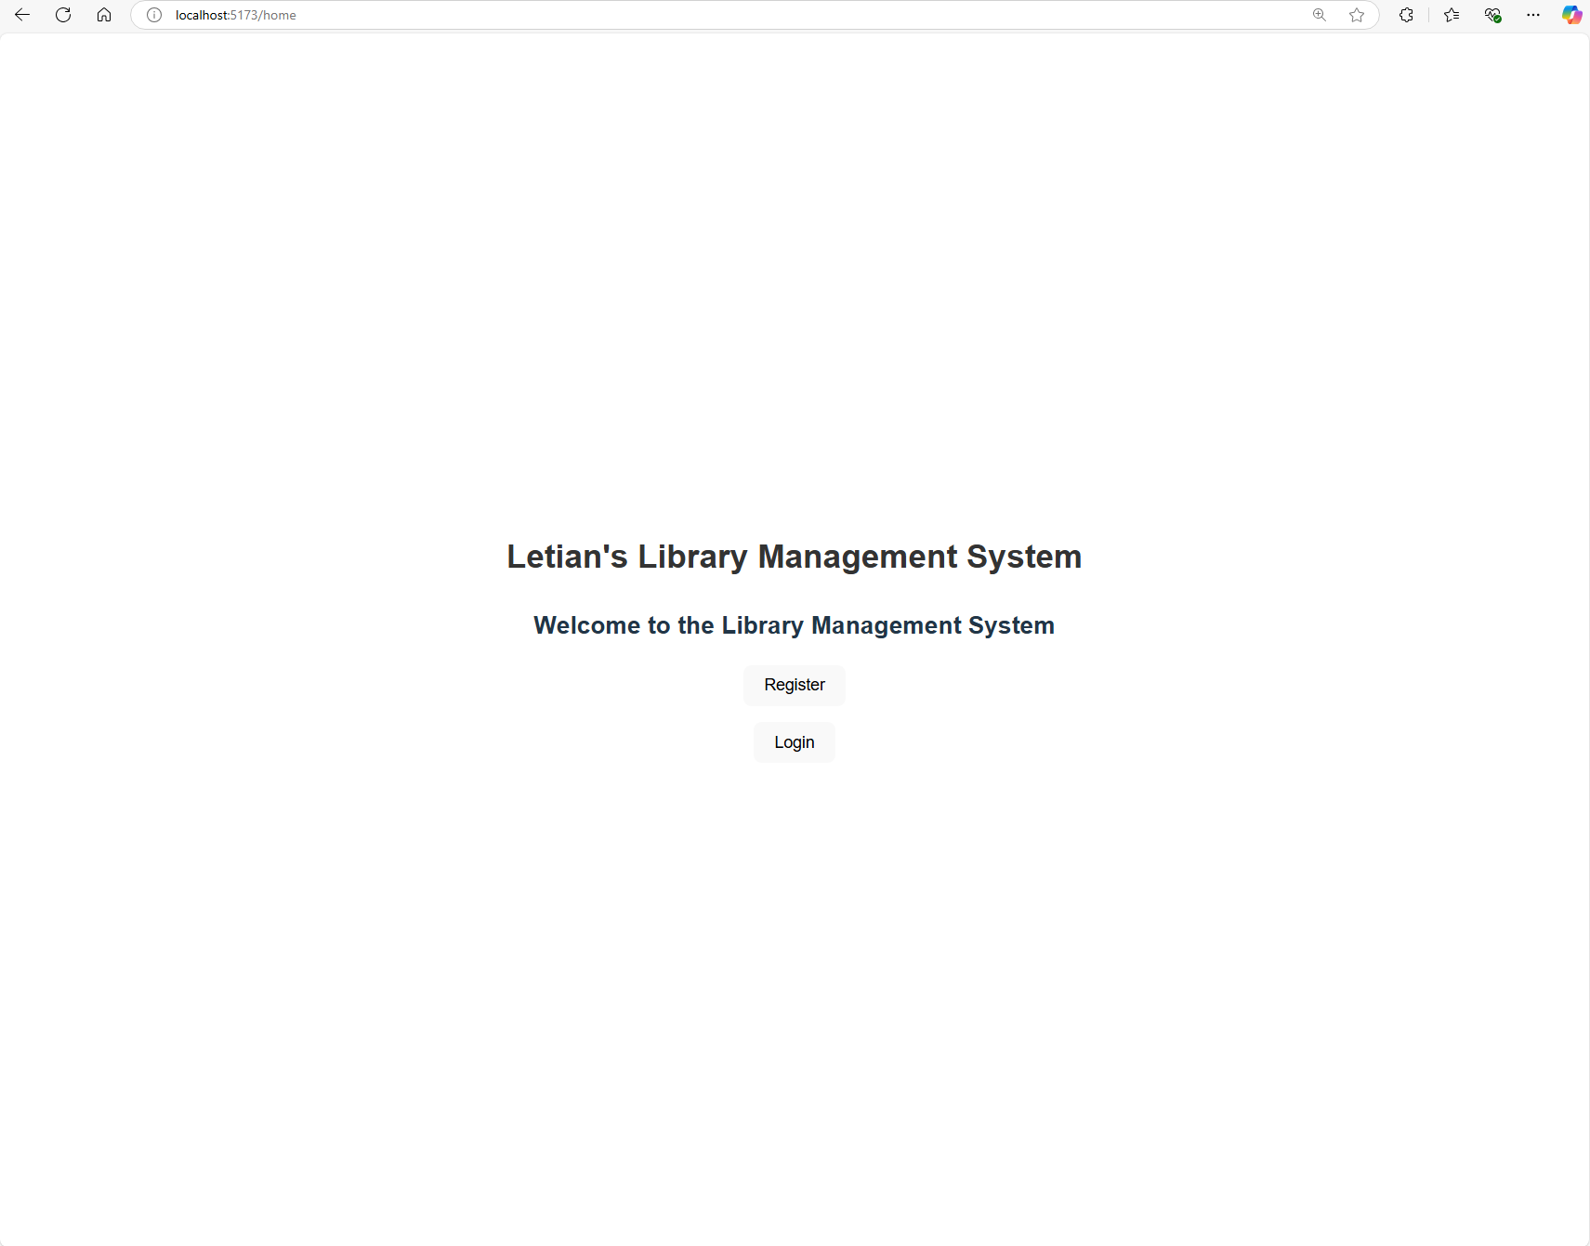
2. User Registration:
   1. User Registration: A user registered here can only be a Member (i.e. not admin), admins are registered using the Admin Portal
      1. 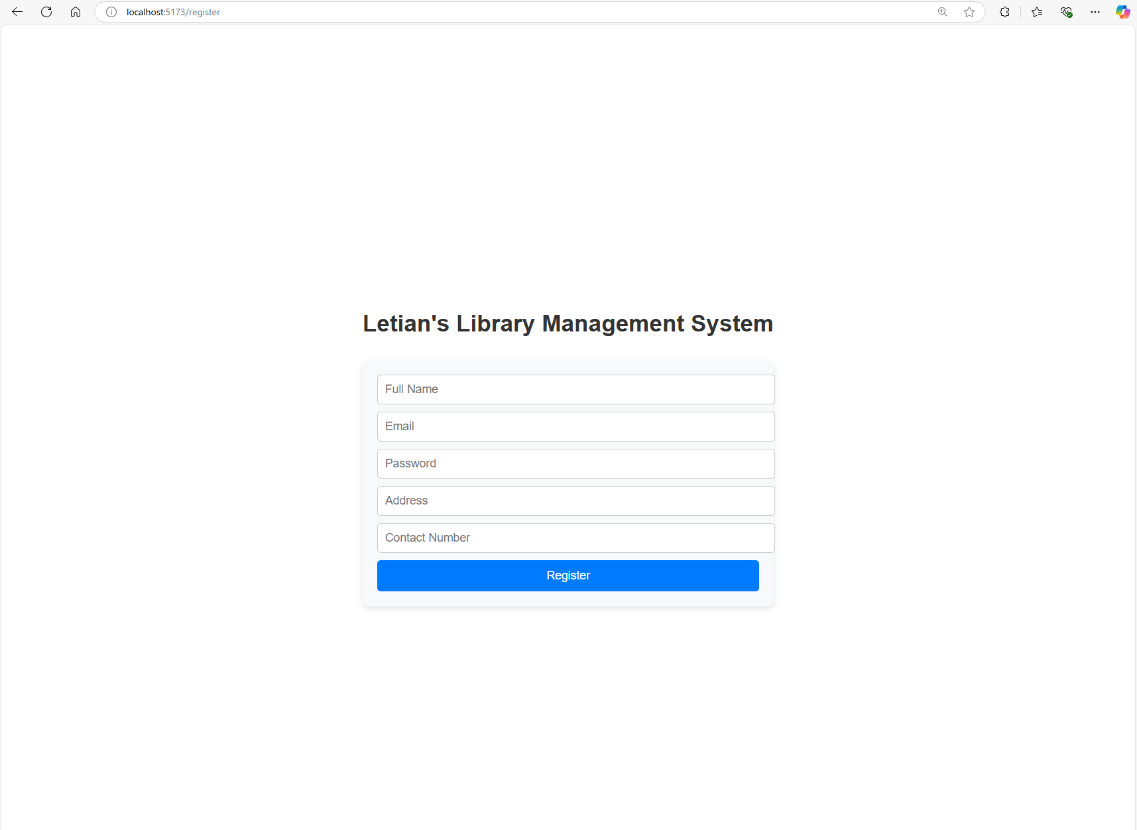
   2. Validation: UserName, Email, and Password are mandatory, Password Length need to be longer than 6, Email format need to contain ‘@’, ‘.c’
      1. UserName is mandatory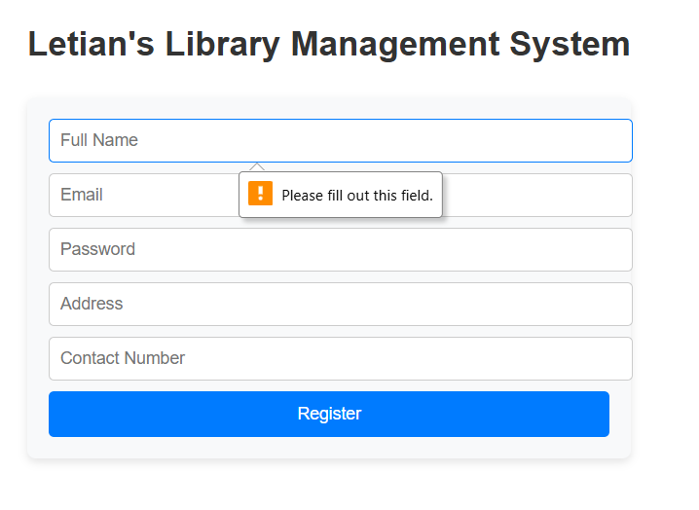
      2. Email is mandatory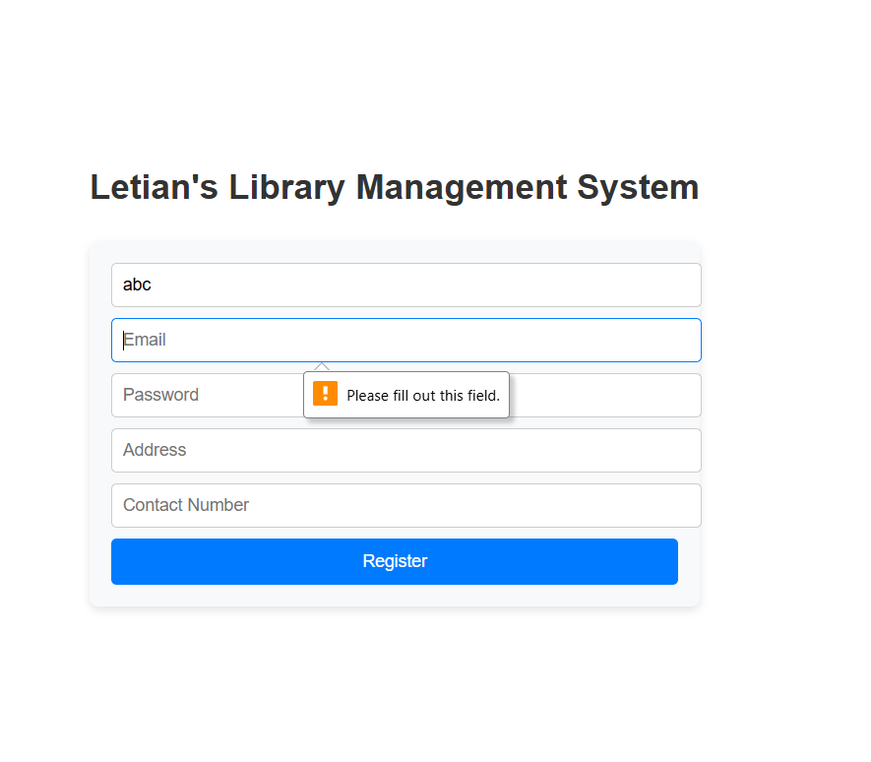
      3. Emails need to fulfill criteria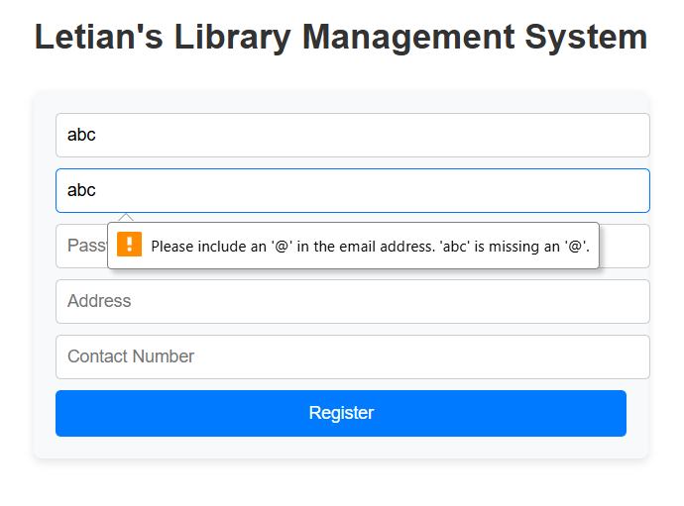

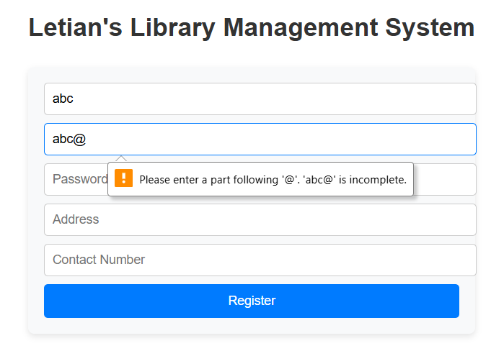

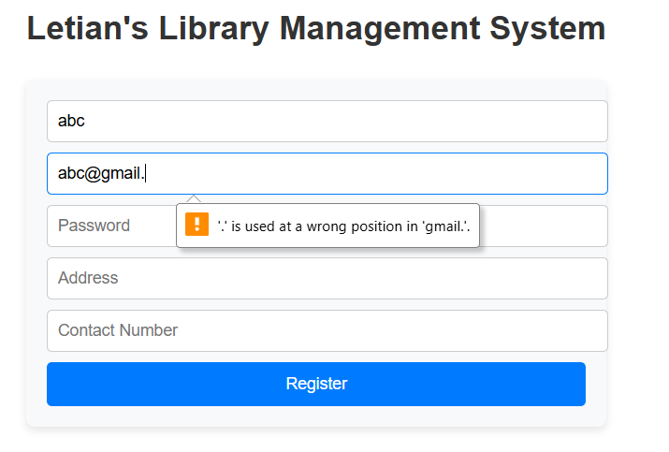

* + 1. Password is mandatory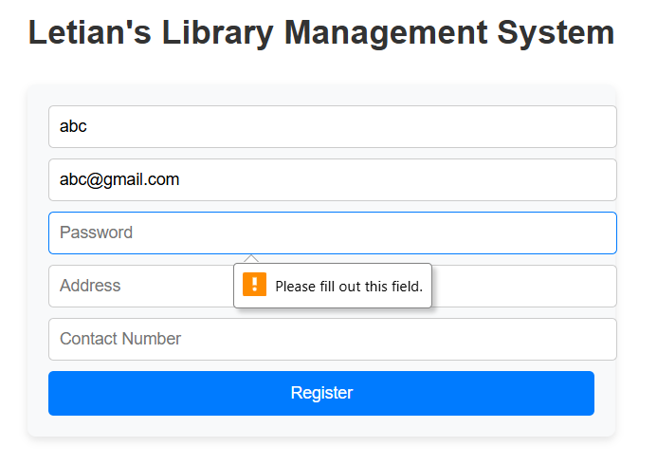
    2. Password needs to be at least 6 characters long, a prompt will appear upon clicking Register while the condition is not being fulfilled 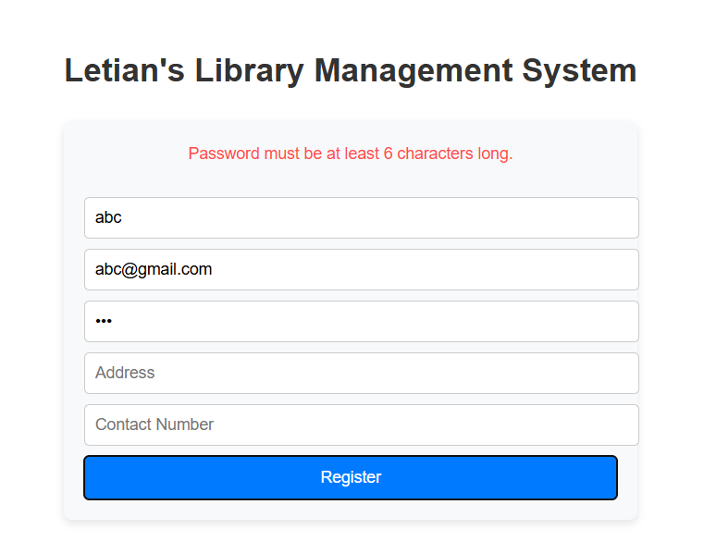
    3. An example of successful registration condition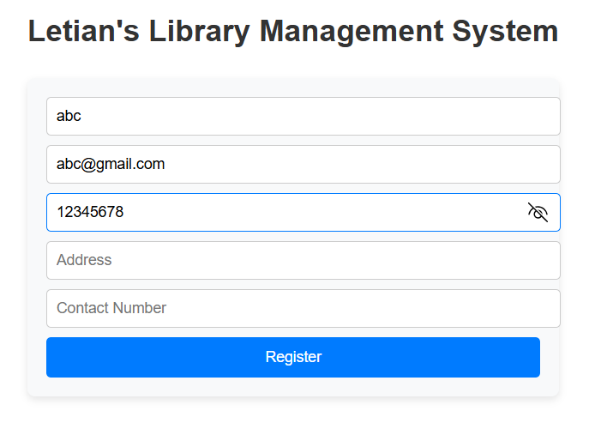
    4. A prompt will appear when the Registration is successful, and the user will be directed to the Login page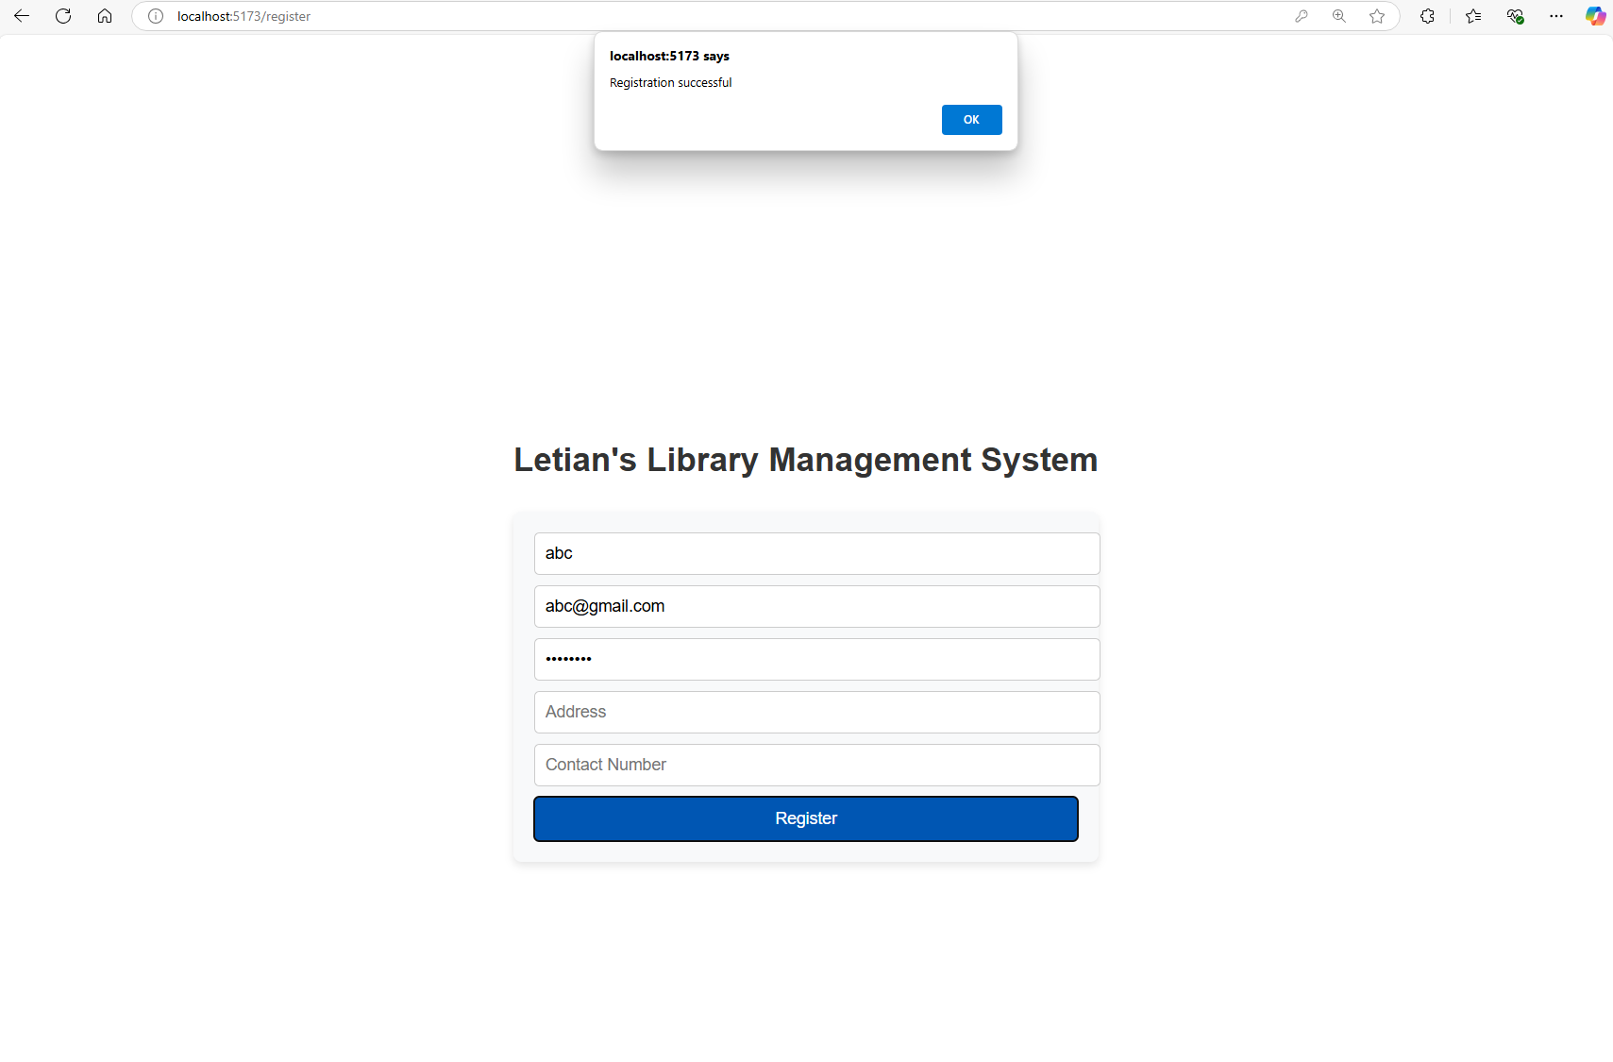

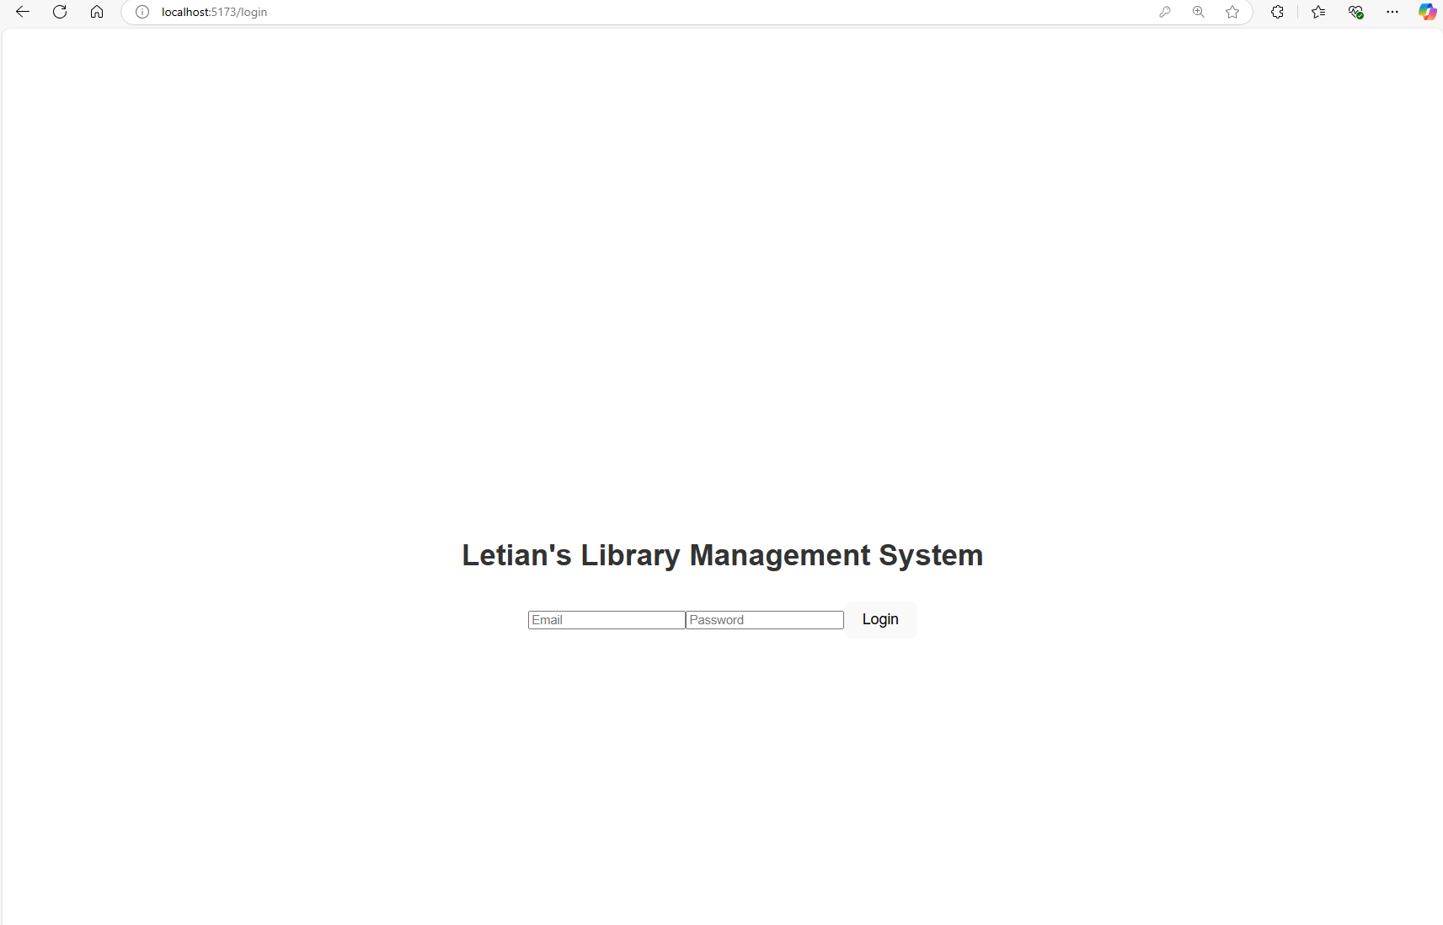

1. User Login: Logged-in users can visit one of the two portals: Admin Portal and Member Portal.
   1. Need to fill in both fields
      1. 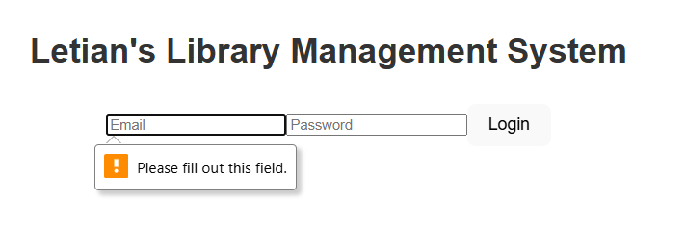
      2. 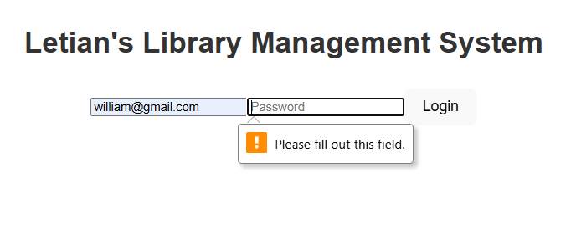
   2. Failed Login:
      1. 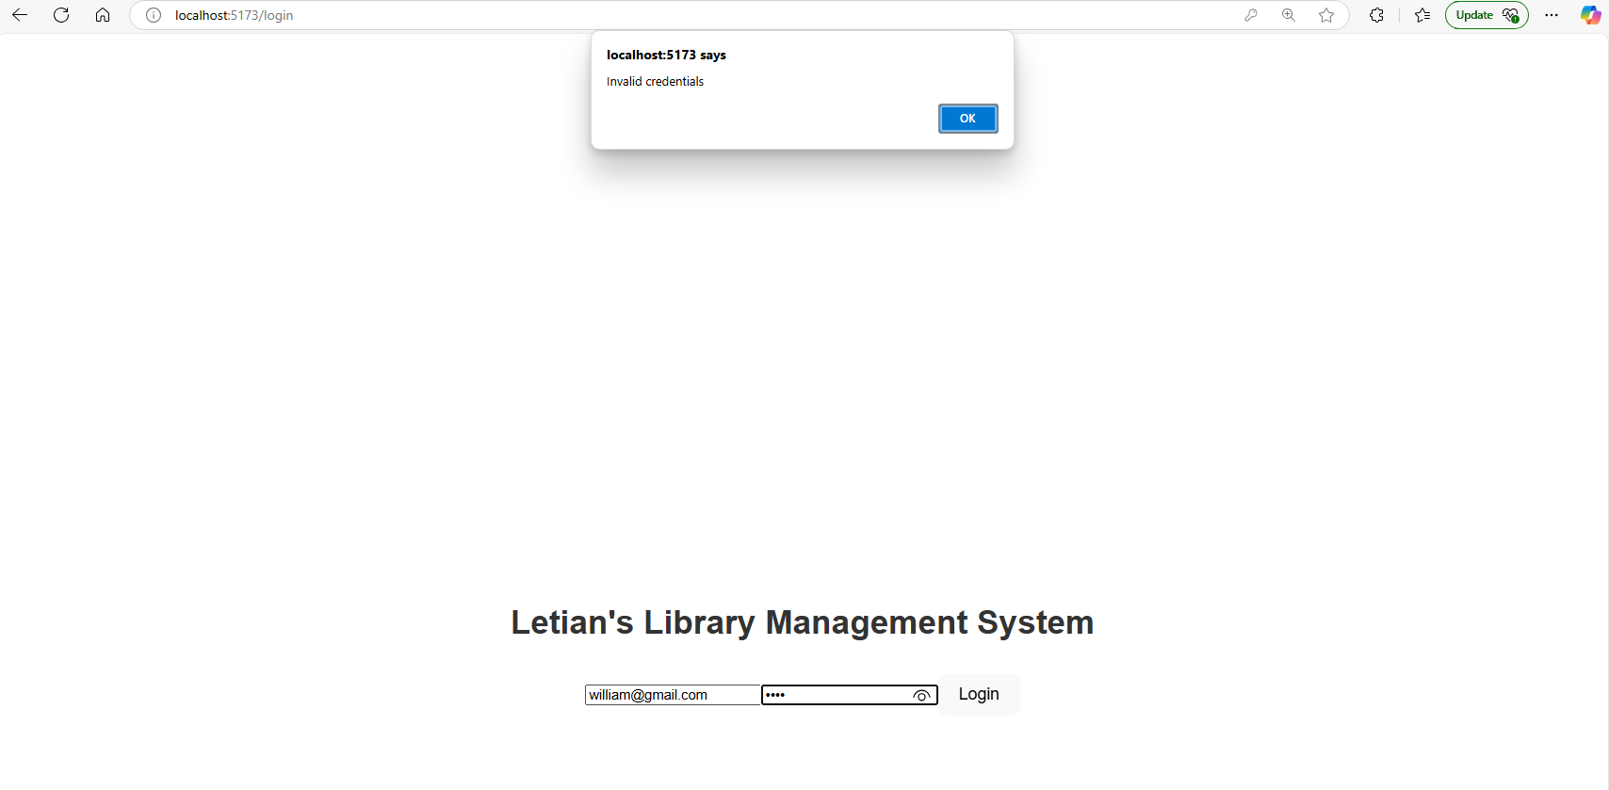
   3. The first screenshot shows the confirmation
      1. 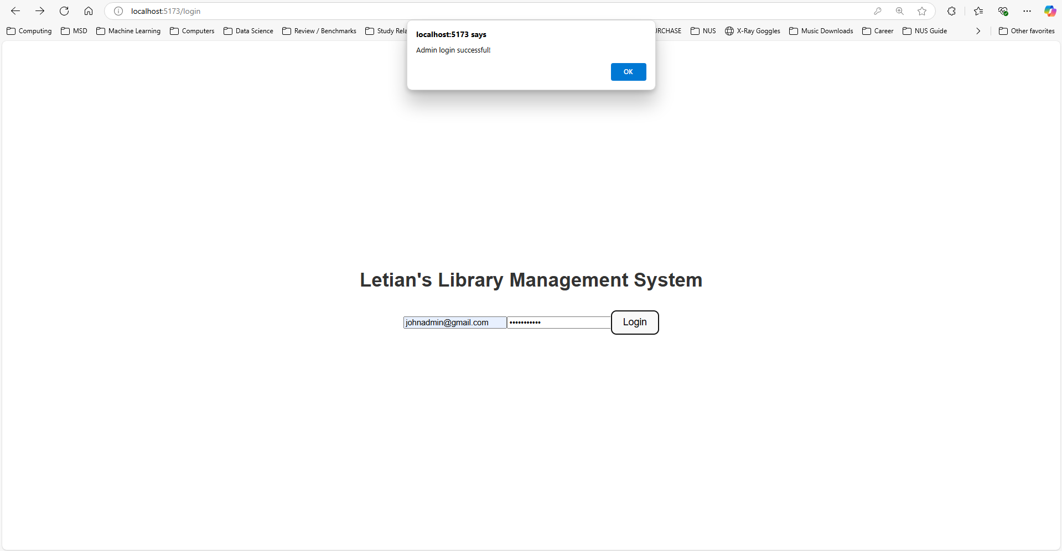
      2. 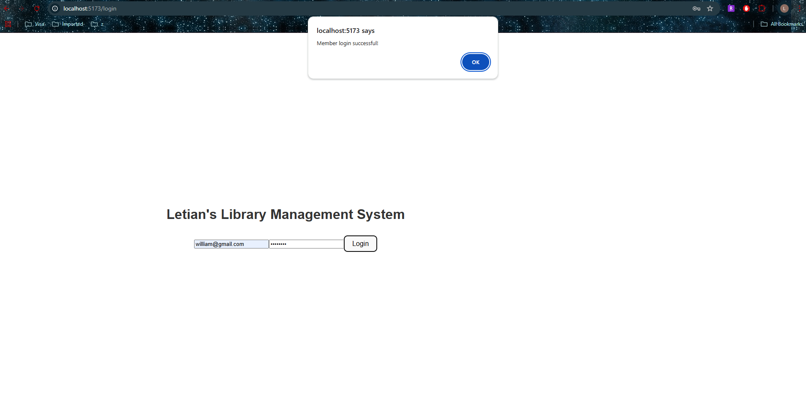
2. Admin Portal:
   1. The Admins will see this screen upon log in. The Admin can visit 2 different systems. The first one is the Book Management System, and the second is the User Management System.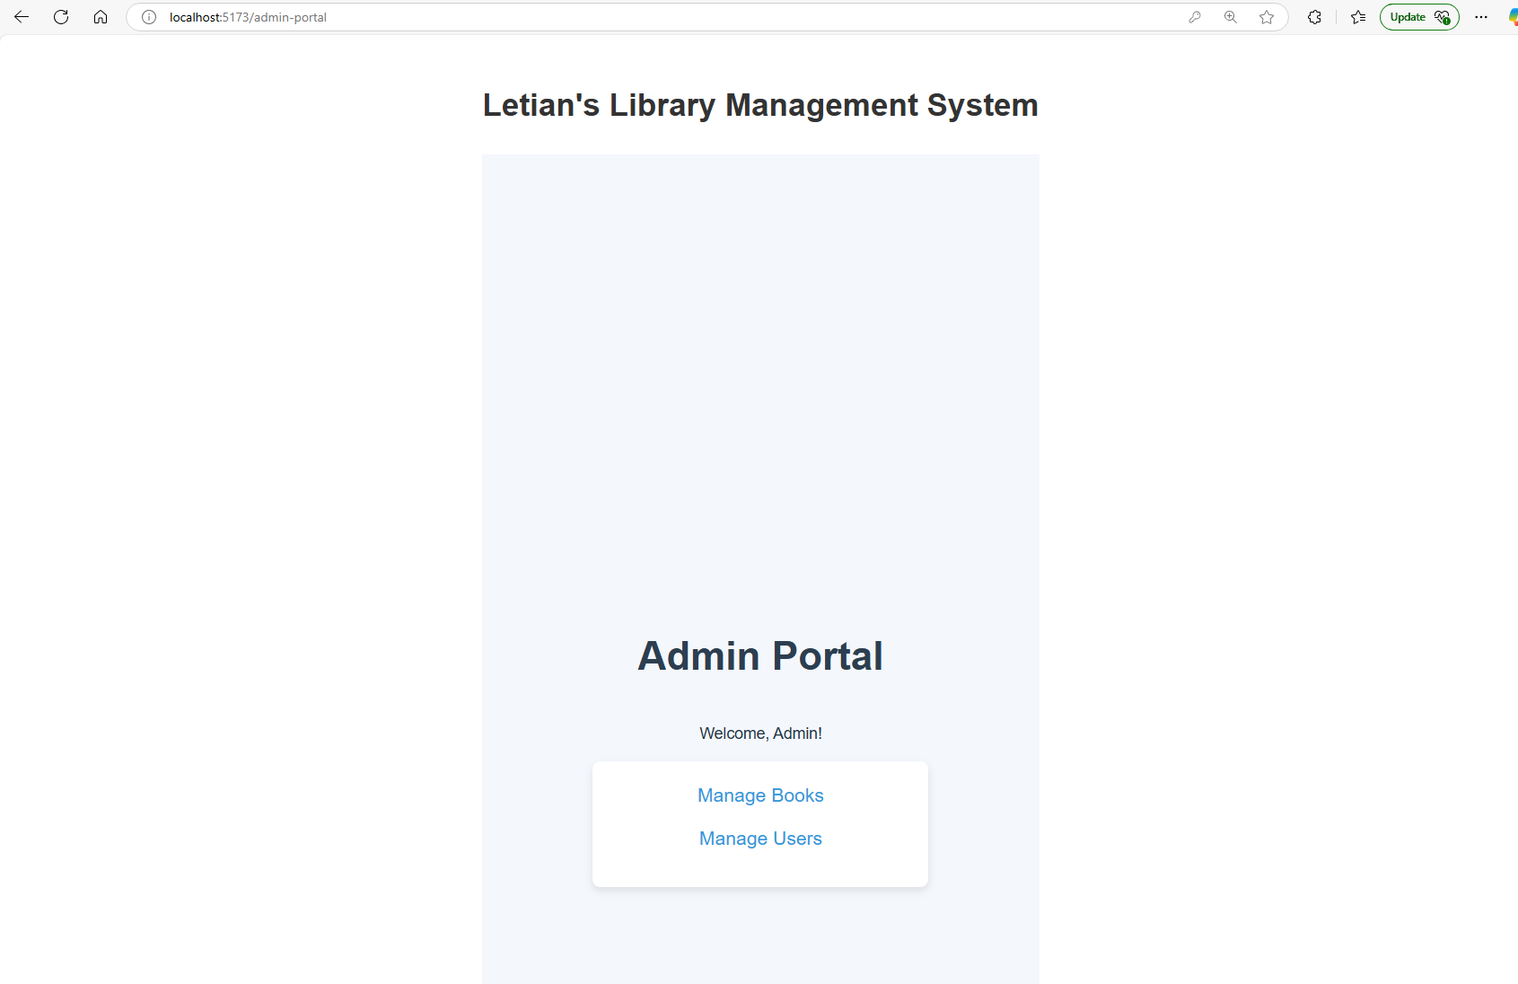
3. Book Management System:
   1. The admin can search a book, add a book, edit, or delete a book
      1. 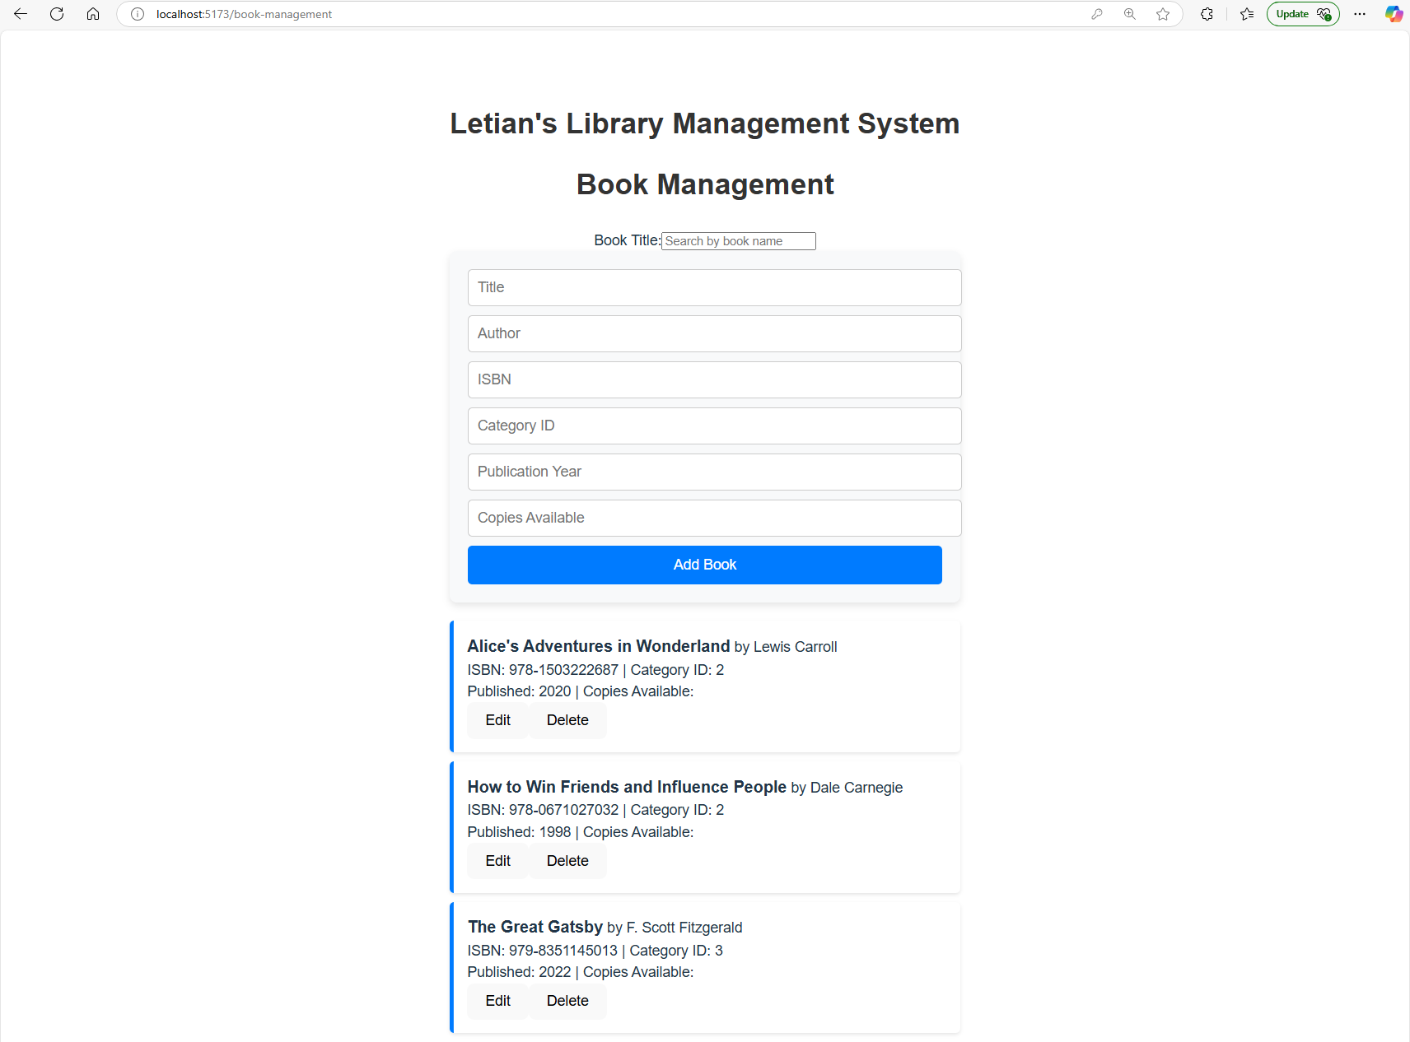
   2. Search a Book:
      1. 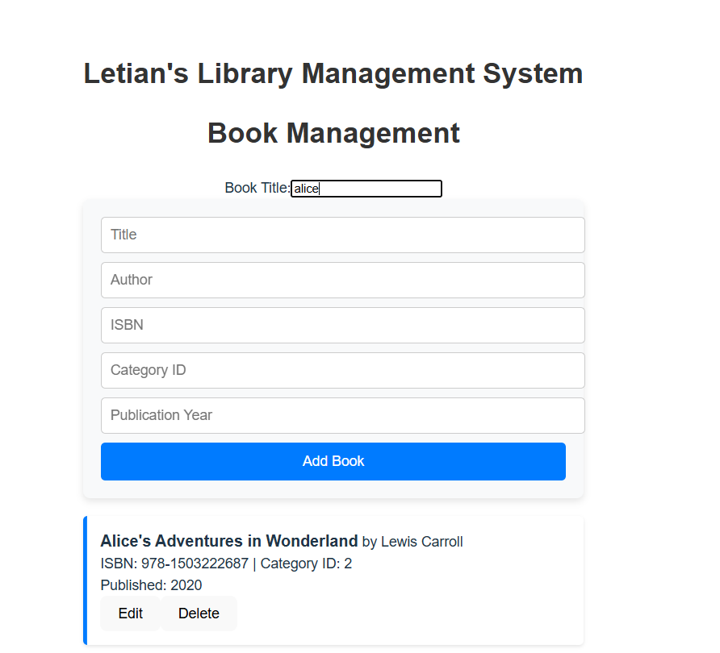
   3. Add Book: All fields must be filled to successfully add a book
      1. 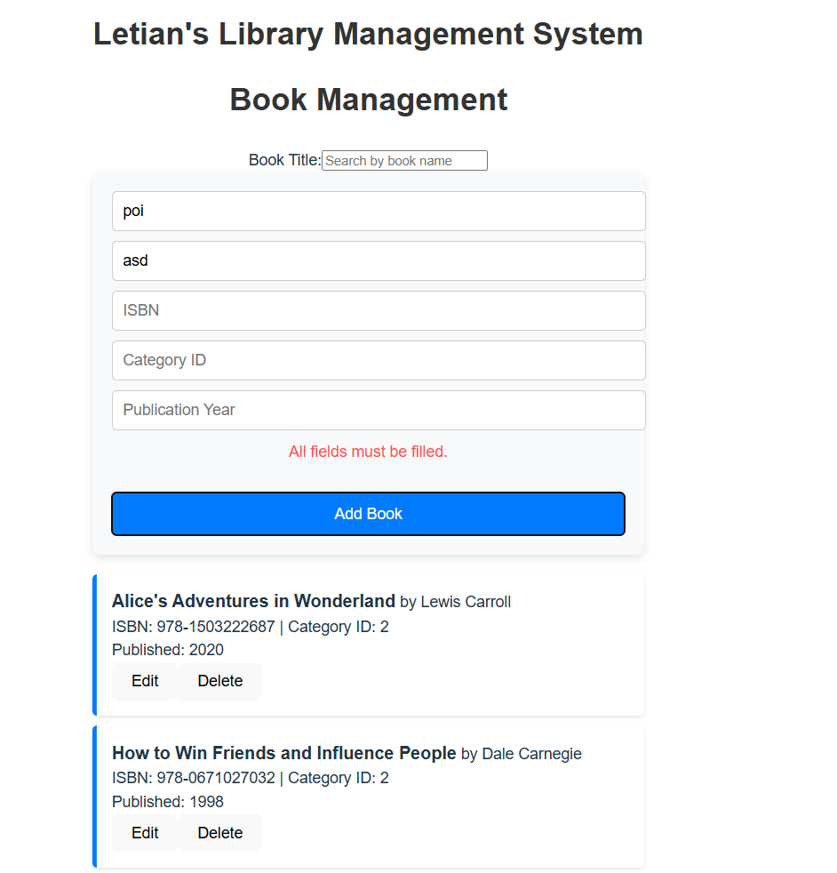
   4. Update a Book: The existing data will be populated and the admin can click on Update Book to update the book info:
      1. 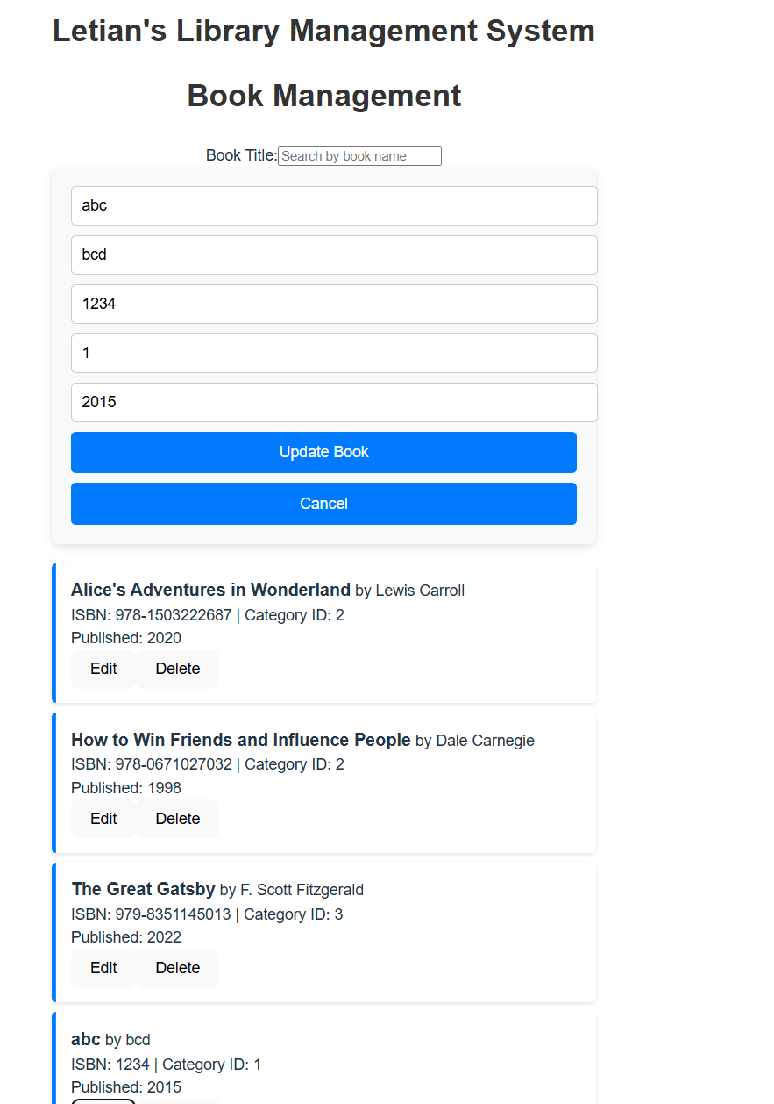
   5. Delete Book: A confirmation prompt will be given before a Book is deleted
      1. 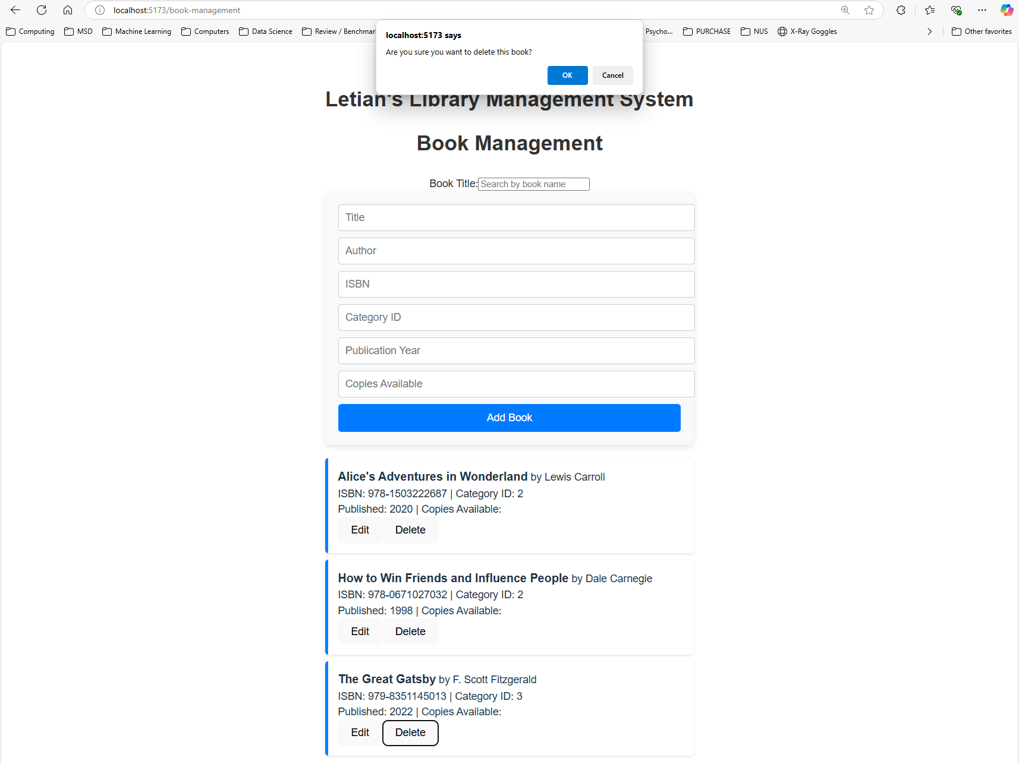
         1. When the delete button is clicked, a confirmation dialog appears.
         2. If the user clicks "OK," the deletion proceeds.
         3. If the user clicks "Cancel," the deletion is aborted.
4. User Management: The admin can search the user by Name, Email, or Roles. The admin can also edit or delete a user.
   1. 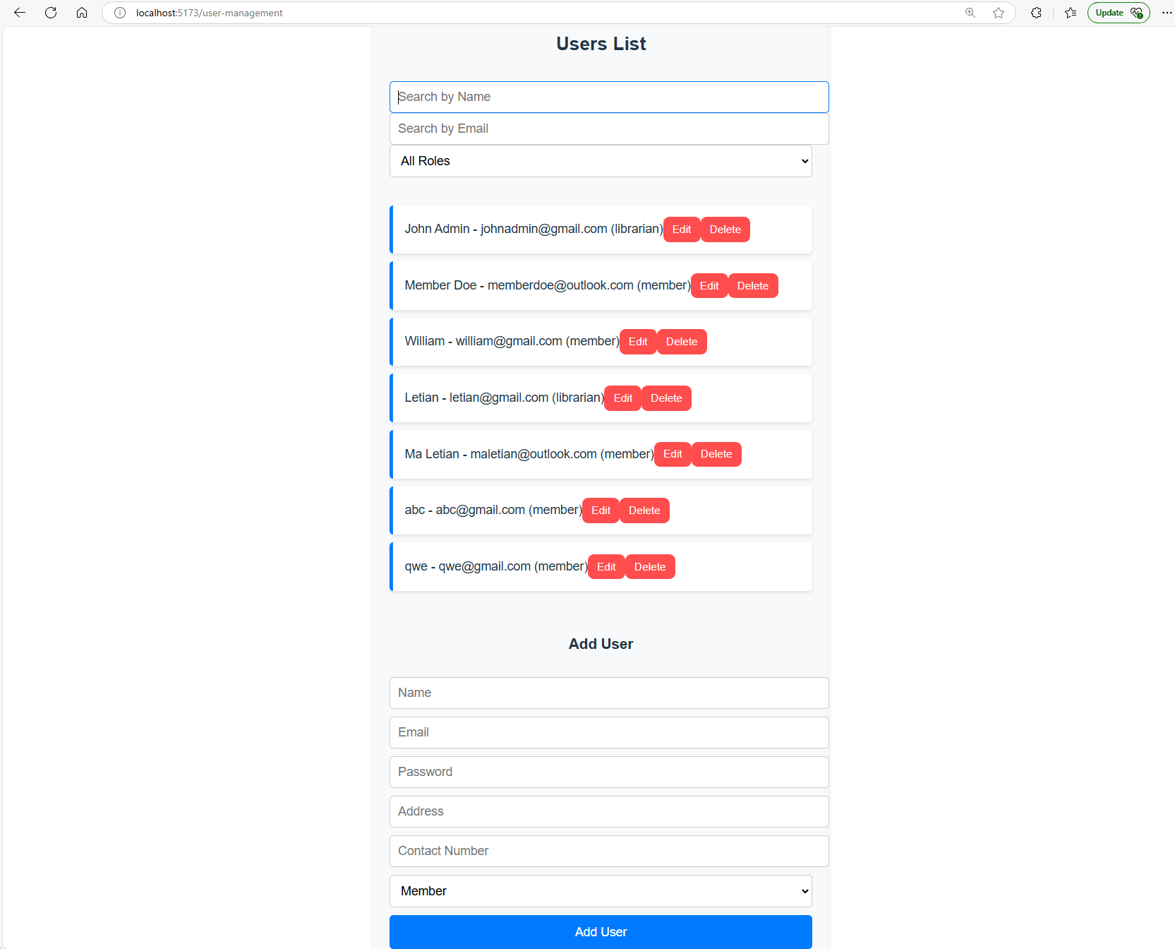
   2. Search:
      1. Search by Name

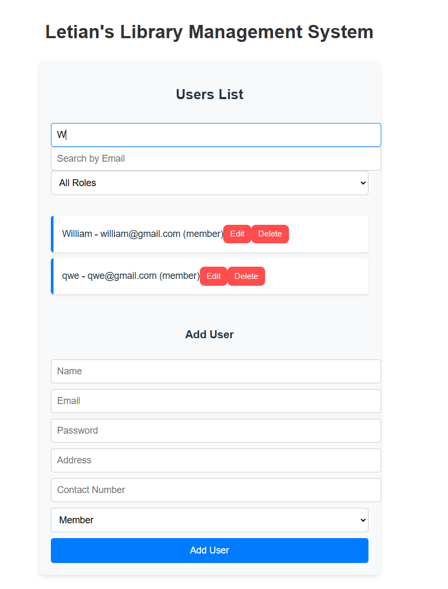

* + 1. Search by Email: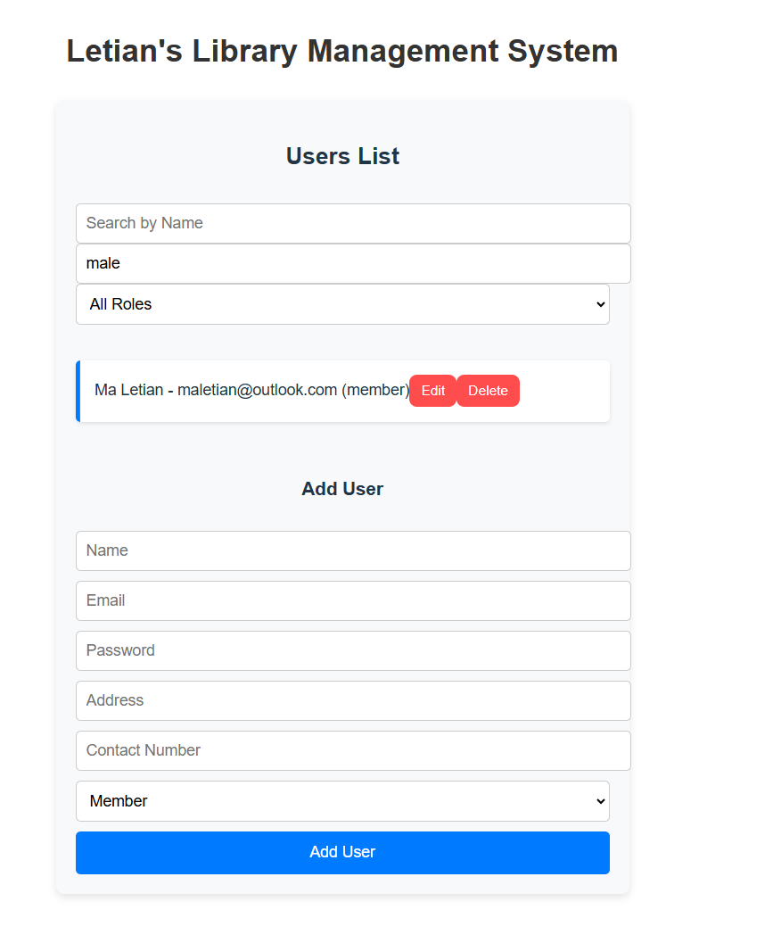
    2. Search by Roles:

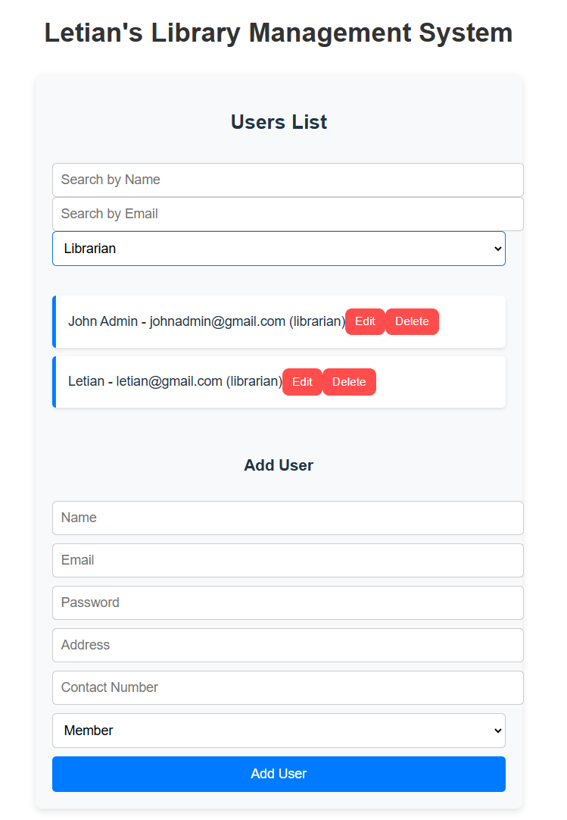

* 1. Add a User:
     1. 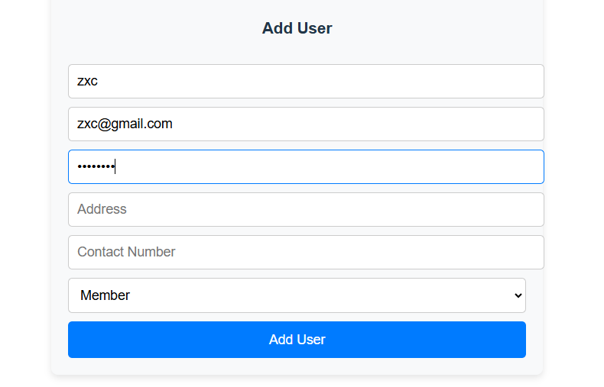
     2. A user can be added as a member (zxc):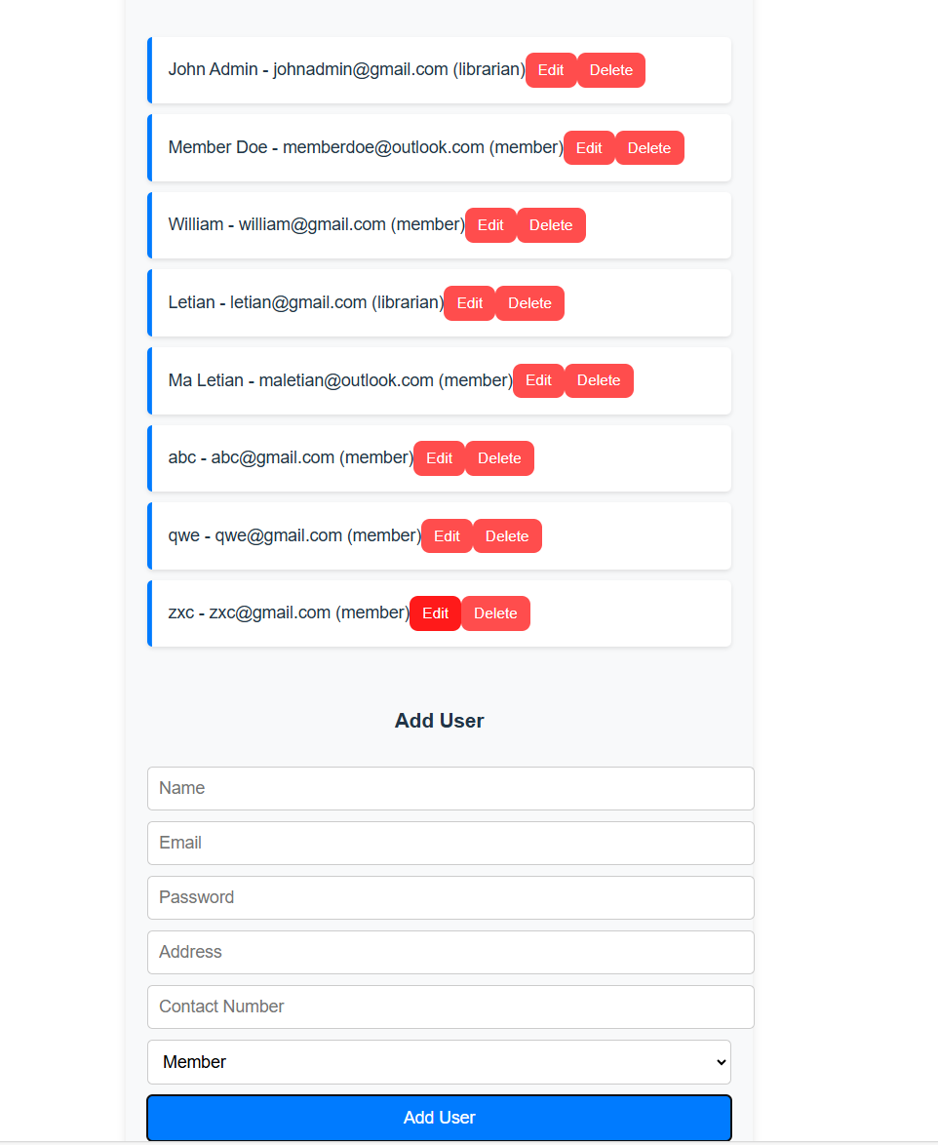
     3. A user can also be added as a librarian (zxc123):

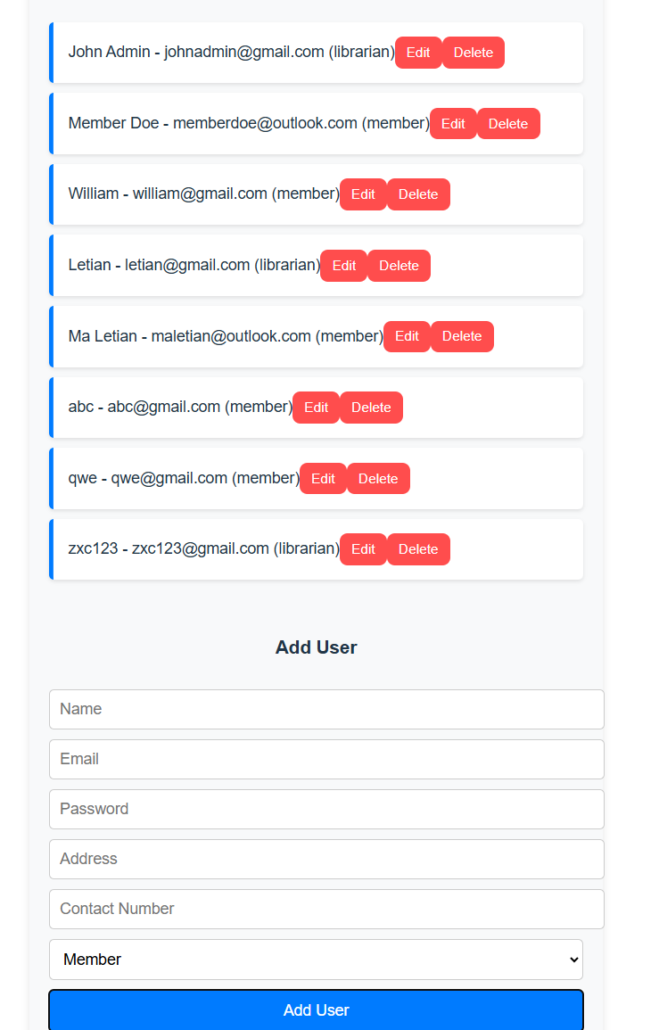

* 1. Edit User:
     1. Similar to Book Management, the existing data will be populated and the admin can click on Update User to update the user info:
     2. 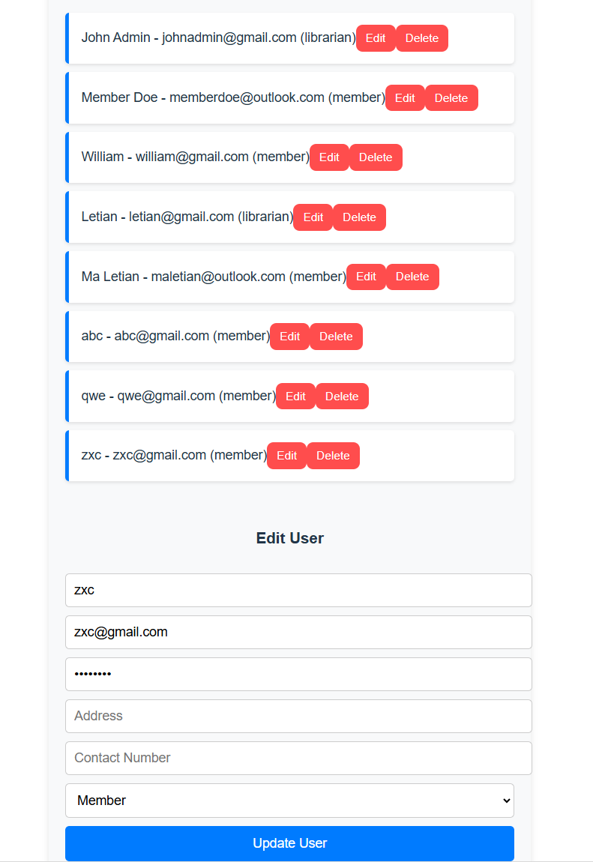
  2. Confirmation before an user is deleted:
     1. 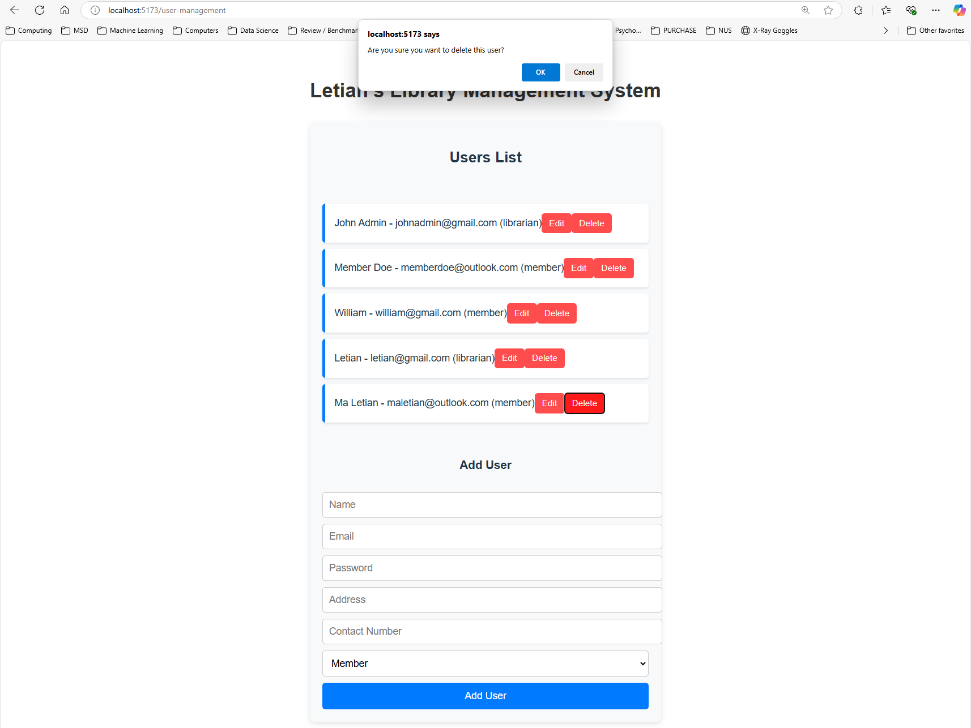
        1. When the delete button is clicked, a confirmation dialog appears.
        2. If the user clicks "OK," the deletion proceeds.
        3. If the user clicks "Cancel," the deletion is aborted.

1. Member Portal:
   1. Member can borrow and view any books that the user has borrowed. Only the Members can log in to this portal.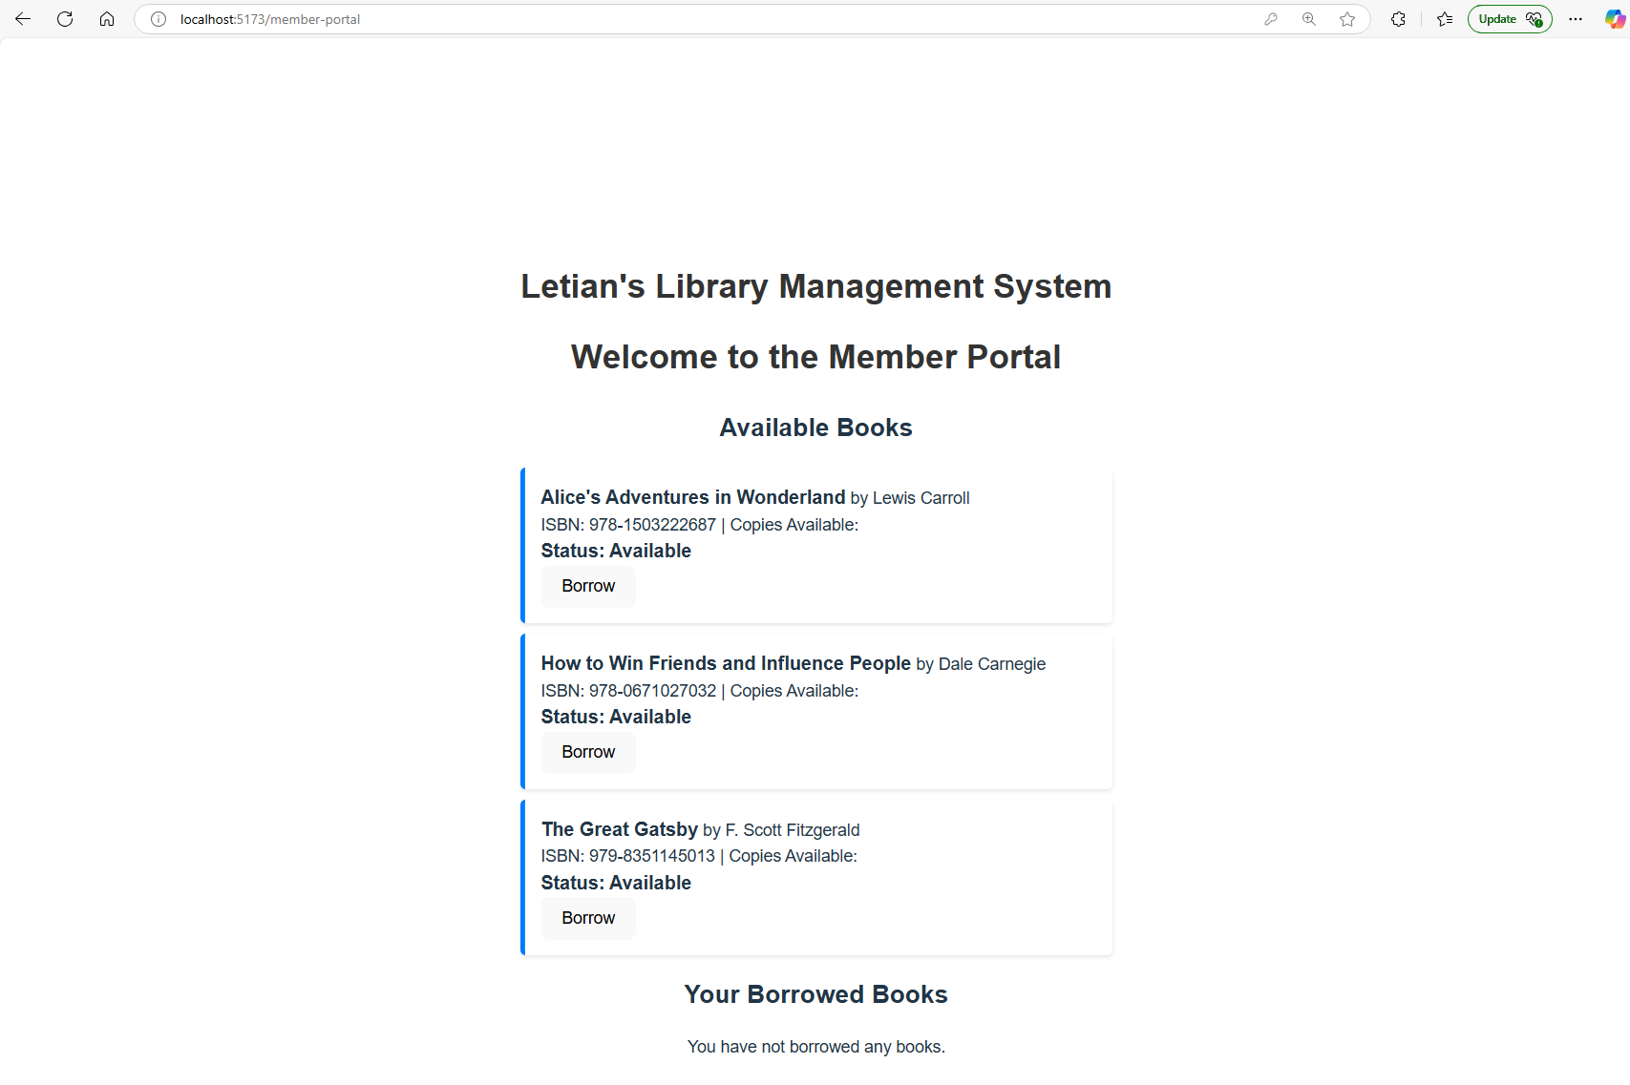
2. Due date are automatically set to 14 days
   1. 